Expt. no: 7 Date:

Designing a 2-sided PCB using vias and net classes in KiCAD 8 for an Instrumentation Amplifier Circuit

Objective
- To use the symbol and footprint created in experiment no. 5 and 6 for IC LM741
- To design a 2-sided PCB layout using vias and netlabels.
- To implement net classes to perform routing with different trackwidths
Equipment
Software: KiCAD 8

Theory

Vias:
In a printed circuit board, vias are holes that pass through the layers of the board for the purpose of conductivity. Each hole functions as a conductive path through which electrical signals are passed between circuit layers. Vias travel through varying levels on a printed circuit board.
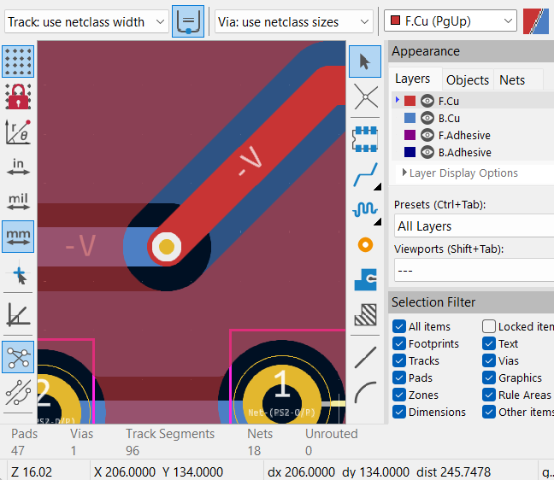
Fig. 7.1 Through-hole via in a 2-sided board

Netlabels:
Labels are used to assign net names to wires and pins. Wires with the same net name are considered to be connected, so labels can be used to make connections without drawing direct wire connections. A net can only have one name. If two different labels are placed on the same net, an ERC violation will be generated. Only one of the net names will be used in the netlist. There are three types of labels, each with a different connection scope.
- Local labels, also referred to simply as labels, only make connections within a sheet. Add a local label with the button in the right toolbar.
- Global labels make connections anywhere in a schematic, regardless of sheet. Add a global label with the button in the right toolbar.
- Hierarchical labels connect to hierarchical sheet pins and are used in hierarchical schematics for connecting child sheets to their parent sheet. Add a hierarchical label with the button in the right toolbar.
We will be using the local label in this experiment.

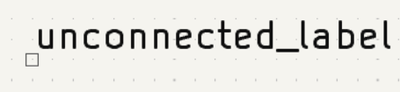
Fig. 7.2 Example of an unconnected local label

Netclasses:
Net classes are groups of nets that can be assigned design rules (for the PCB) and graphical properties (for the schematic). More than one net class can be assigned to a net (through a combination of graphical assignments and net class patterns). For nets with multiple net classes assigned, an effective aggregate net class is formed, taking any net class properties from the highest priority net class which has that property set. Net class priority is determined by the ordering in the Schematic or Board Setup dialogs. The Default net class is used as a fallback for any missing properties after all explicit net classes have been considered.

Net classes may be created and edited in either the Schematic or Board Setup dialogs. Nets can be added to net classes in either the schematic or board using pattern-based assignments. Nets can also be assigned to net classes in the schematic using graphical assignments with net class directives or net labels. Selecting a wire or label displays the net’s net class in the message panel at the bottom of the window.

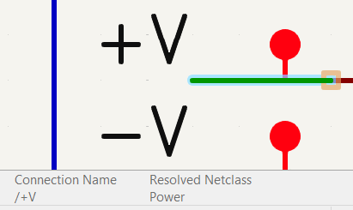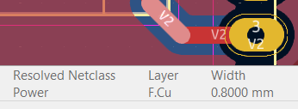
Fig. 7.3 Resolved Netclass displayed on selection of a wire in schematic and a track in PCB Layout

We will be using net classes to handle the trackwidths of routes.

Procedure
- Design the schematic layout using the new symbol and netlabels to avoid too many wires:
  - Set grid and page settings.
  - Add symbols to the sheet according to the circuit diagram.
  - Arrange, wire, and annotate symbols, and add textual information. Ensure readability.
  - Associate symbols with footprints using the Footprint Assignment Tool.
- Create net classes power and signal:
  - In the PCB Editor, Go to File> Board Setup. Select the Net Classes setting under the Design Rules section on the left pane.
  - In the Netclasses section, add two new netclasses: Power and Signal. Change the track widths of each class according to your requirements. Click OK.
- Assign net classes to the nets in the schematic layout:
  - Add Directive labels with the button in the right toolbar. They behave like labels, except that they cannot be used to name a net, instead the attached net is assigned a net class according to the value of the directive’s Net Class field. The Net Class field presents a dropdown list of all the net classes in the design.
  - If a directive is attached to a net, all wires connected to the net are assigned to the specified net class. Attach directive labels to nets as necessary.
- Perform an electrical rules check (ERC), fix errors, and repeat. Export netlist.
- Design the PCB Layout using new footprint, net classes, and vias:
  - Set grid and page settings.
  - Import netlist.
  - Place components according to functional blocks and user interface.
  - Route the tracks (ensure trackwidths appear according to net classes), perform a zone fill, and add textual information.
  - Perform Design Rules Check (DRC), fix errors, repeat.
  - Create, verify, and export the Gerber files and Excellon drill files.
Circuit Diagram:
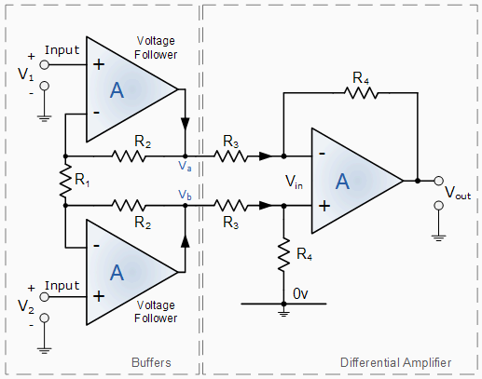

Fig. 7.4 The Instrumentation Amplifier using IC LM741

Implementation:
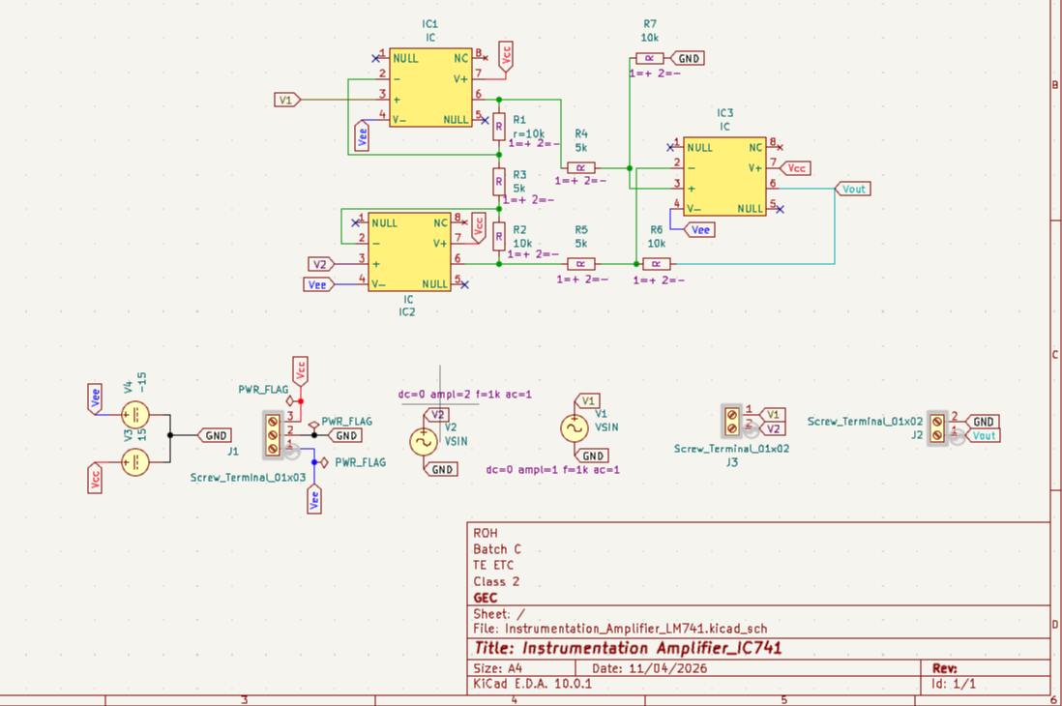
Fig. 7.5 Schematic Layout of the circuit after ERC

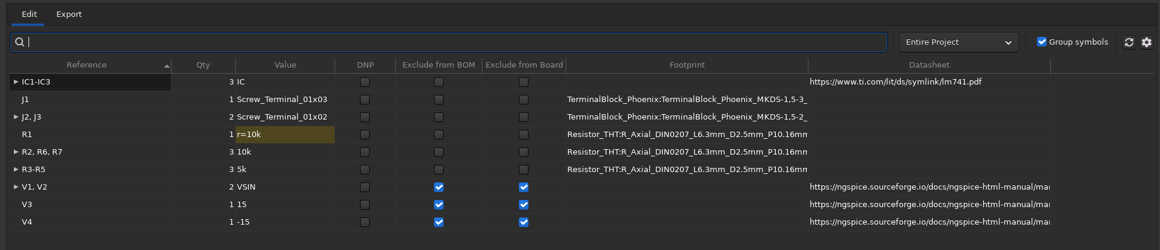
Fig. 7.6 Bill of Materials (BOM)
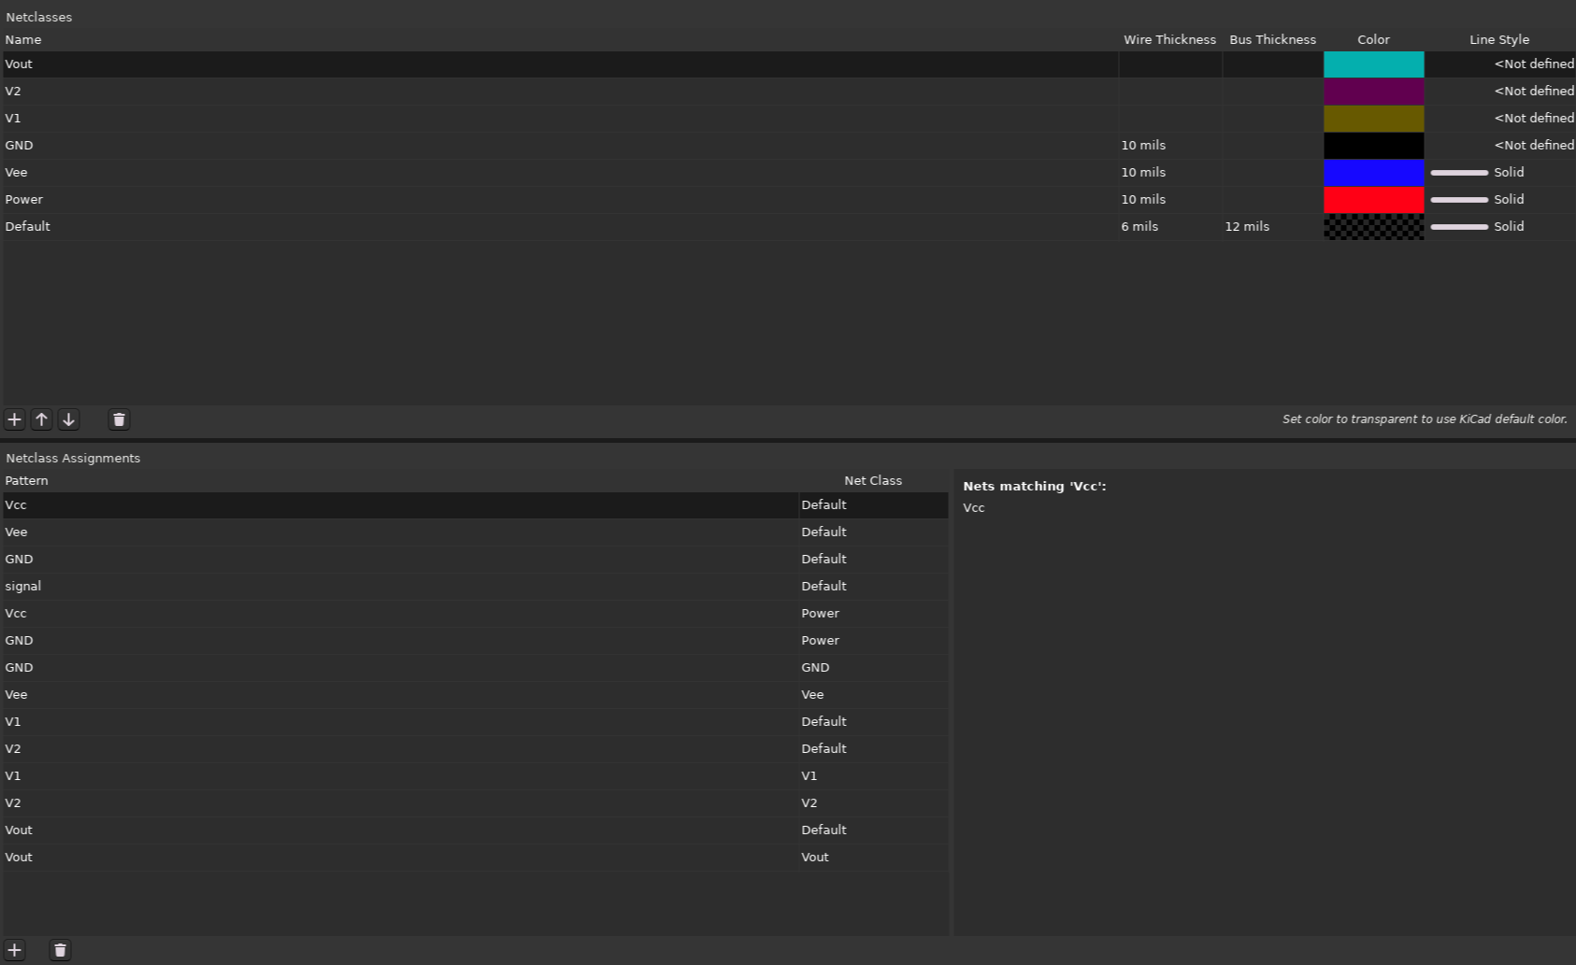
Fig. 7.7 Netclasses Created

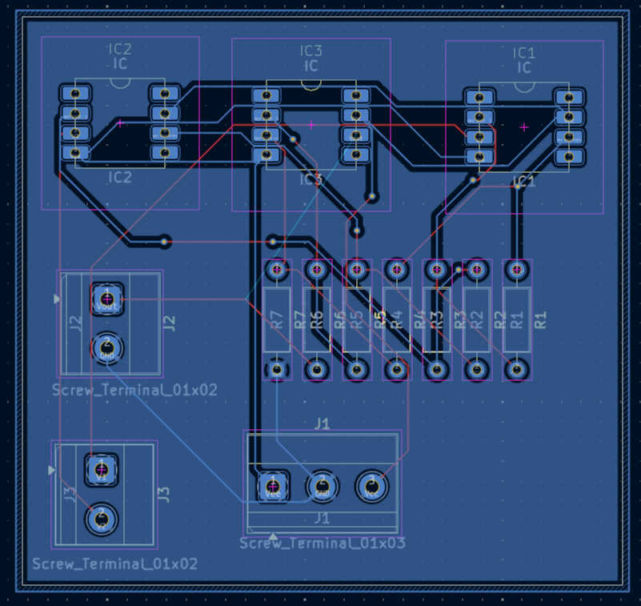
Fig. 7.8 PCB Layout after DRC with Routed Rracks and Zone-Fill

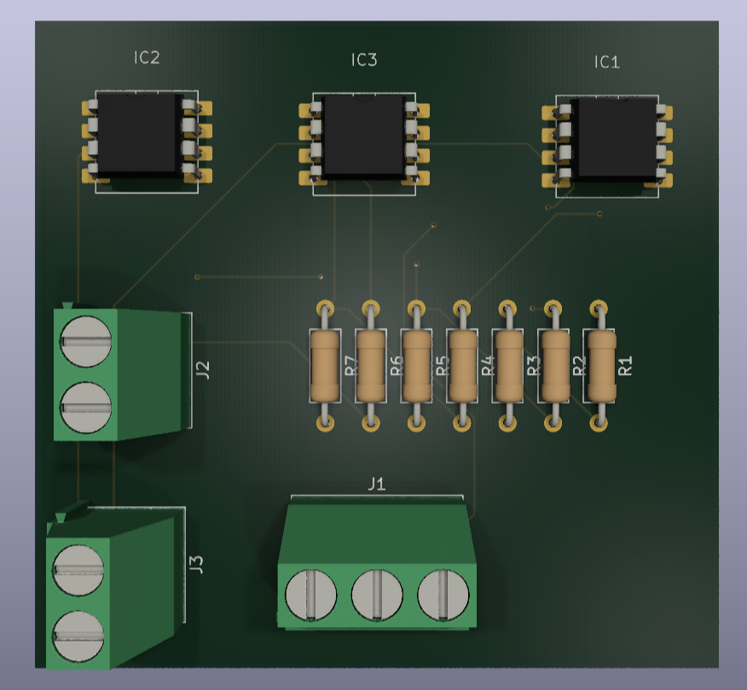
Fig. 7.9 Component-Side 3D View
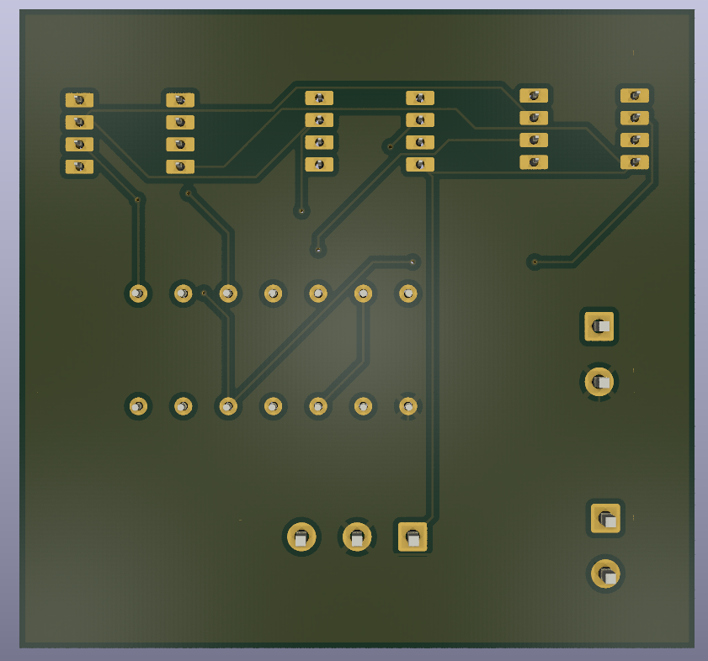
Fig. 7.10 Solder-Side 3D View

Fig. 7.11 Back Copper and Front Copper Gerber and Excellon Drill Files in Gerber Viewer

Challenges: The main challenge I came across was navigating through the rat’s nest in the PCB layout. It took a while to trace the most optimal paths. To make the problem easier, I used the Back Copper layer exclusively for the power supply area and utilized the Front Copper layer for everything else. This approach helped streamline the routing process and made the PCB layout more organized.

Conclusion: The following objectives were successfully achieved:
- The symbol and footprint created in experiments no. 5 and 6 for IC LM741 were used.
- A 2-sided PCB layout was designed using vias and netlabels.
- Net classes were implemented to perform routing with different trackwidths.

